Emily Thamm | 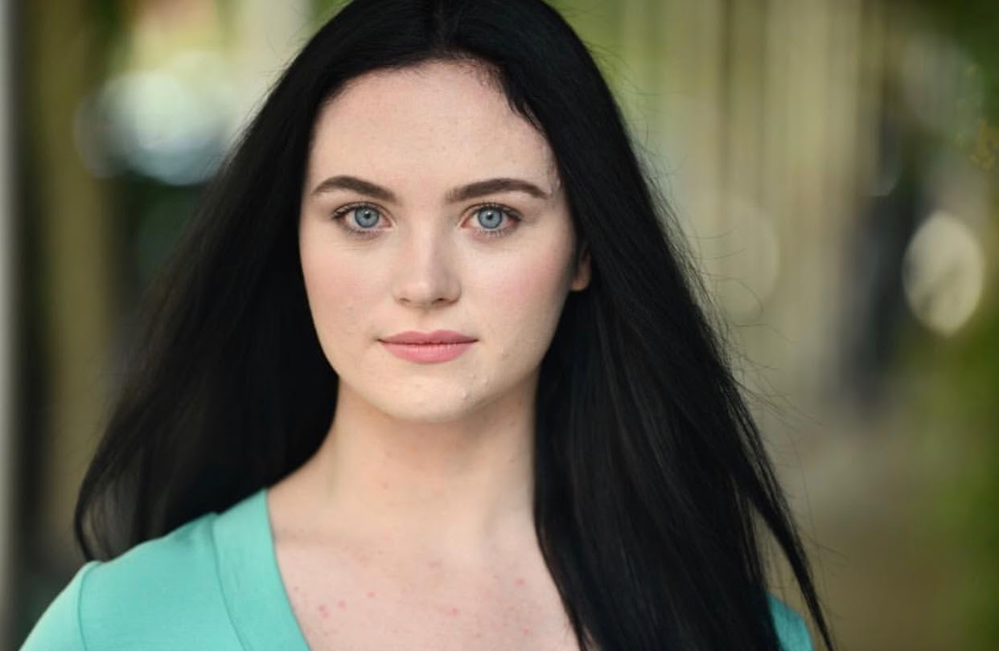

Height: 5’8
Weight: 120
Hair: Black Eyes: Blue
Voice: Mezzo-Soprano
Range: A3-F5
ethamm1@pride.hofstra.edu
(123) 456-7890
1000 Hempstead Turnpike
Hempstead, NY 11549

Performing Experience
Kings Park Dance Center Kings Park, NY Competitive Dancer (2003-2014)
Next Generation of Dance East Northport, NY Competitive Dancer (2014-2015)
East Coast Artists Dance Center Smithtown, NY Competitive Dancer (2015-2016)
Geneseo Dance Ensemble Geneseo, NY Concert Dancer (2016-2019)
Geneseo Knightline Dance Team Geneseo, NY Dancer (2016-2018)
Geneseo Orchesis Dance Club Geneseo, NY Showcase Dancer (2016-2019)
Geneseo Musical Theatre Club Geneseo, NY Dancer/Singer/Actress (2018-2019)
Geneseo Festival Singers Geneseo, NY Alto 1 Choir Singer (2019)
An Iliad Geneseo, NY Narrator (2019)
Ordinary Days Geneseo, NY Ensemble (2019)
No Laugh Track Required Geneseo, NY Improv Comedy Troupe Member (2019)
Hofstra Danceworks Productions Hempstead, NY Showcase Dancer (2020)

Modeling Experience
Kinetic Dancer/Model
Dance Lifestyle Magazine Dancer/Model
Training

Kings Park Dance Center Kings Park, NY dir. Sandra Campagnolo-Moletto

Next Generation of Dance East Northport, NY dir. Amy Pellicane

East Coast Artists Dance Center Smithtown, NY dir. Joe Crescimanno and Dan Longo

Joffrey Ballet School New York, NY dir. Jo Matos

Joffrey Jazz/Contemporary
Intensive New York, NY dir. Angelica Stiskin

Joffrey Musical Theatre Intensive New York, NY dir. Max Baud and Matthew Prescott

Broadway Dance Center New York, NY dir. Reese Snow

Rockettes Summer Intensive New York, NY dir. Shauna Caulfield

American Academy of
Dramatic Arts New York, NY dir. Jonathan Bolt

Grace Music School New York, NY dir. Grace Heaphy

SUNY Geneseo Dance Department Geneseo, NY dir. Jonette Lancos

SUNY Geneseo Music Department Geneseo, NY dir. Gerard Floriano

Hofstra University Dance
Department Hempstead, NY dir. Rachel List

Schooling

Ivy League School Smithtown, NY 2002-2012

Northport High School Northport, NY 2012-2016

SUNY Geneseo Geneseo, NY 2016-2019

Hofstra University Hempstead, NY 2019-anticipated graduation in 2020
with a Bachelor of Arts Degree in Dance

Special Skills

- Has a United States passport
- Comfortable being lifted
- Sight reading
- Intermediate level Spanish
- Improvisation
- Comfortable working with animals
- Choreographing and directing experience

